“We love because God first loved us.” – 1 John 4:19

This year’s Dakotas Annual Conference theme is “Created for Love” and will center around the words of 1 John 4:7-21 – a reminder that the love we were created for is lived out in tangible, incarnational ways. One such act of love is our Miracle Offering – an annual act of hope, generosity, and grace that extends our reach beyond what any one congregation could do alone.
This year, the 2025 Miracle Offering will support the ongoing, life-giving work of the United Methodist Committee on Relief (UMCOR).
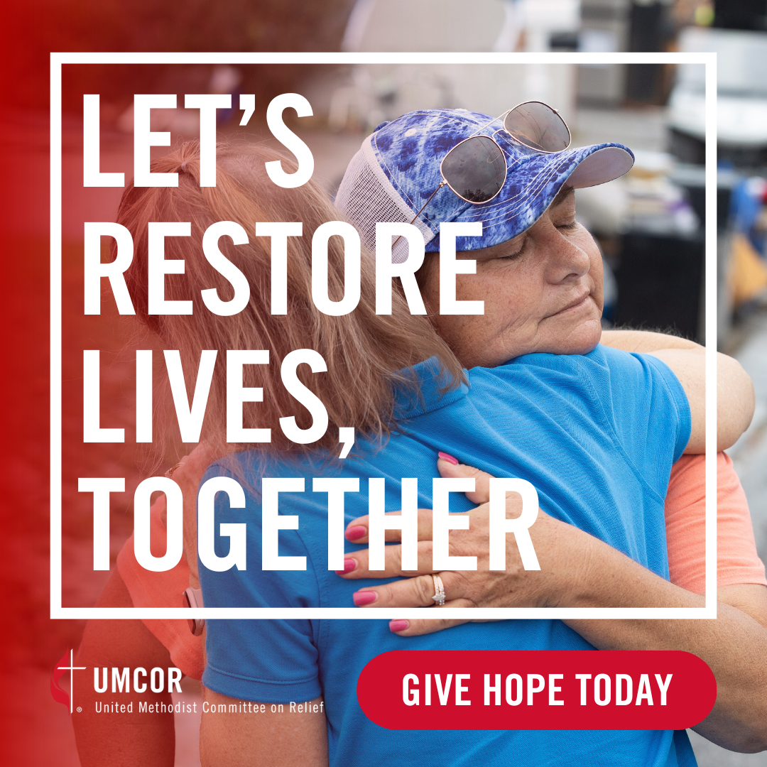
The work of UMCOR is a true symbol of our United Methodist faith and connection in action and a powerful example of incarnational love. Whether responding to natural disasters, addressing global food insecurity, attending to urgent health needs, or equipping communities with clean water and hygiene kits, UMCOR is often the first to arrive and the last to leave. Every act of relief, every rebuilt home, every safe space provided, every life cared for is an embodiment of love made visible.

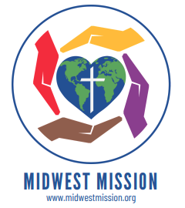
In addition to giving financially to the Miracle Offering, we invite Dakotas United Methodists to collect items for Midwest Mission. Midwest Mission, located in Jefferson, Iowa, is one of the mission depots that partners with UMCOR to quickly and effectively respond following a disaster with Home Care Kits (formerly known as Flood Buckets) and Personal Dignity Kits, along with other items.

In a world where so many feel forgotten, abandoned, or overwhelmed by crisis, our partnership in the work of UMCOR bears witness to the love of Jesus in this world. We proclaim, with courage and compassion, that love still leads. Because God first loved us, we extend that love through action—through giving, serving, and showing up. The role of the church—the Body of Christ that is created for the purpose of loving our neighbors—has never been more critical…Please invite the members and friends of your congregation to join in this shared act of generosity and incarnational love. Every gift, whether large or small, is part of a greater miracle that says to a hurting world: You are not alone. You are beloved. —Bishop Lanette Plambeck


For additional information and resources, go to the following websites:
www.dakotasumc.org
www.midwestmission.org
www.umcmission.org/umcor

